**LABORATORY PROGRAM – 7**

Write a program that demonstrates handling of exceptions in inheritance tree. Create a base class called “Father” and derived class called “Son” which extends the base class. In Father class, implement a constructor which takes the age and throws the exception WrongAge( ) when the input age=father’s age.

**OBSERVATION :**

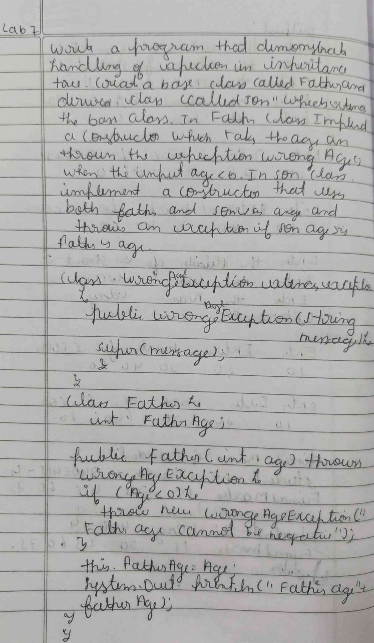

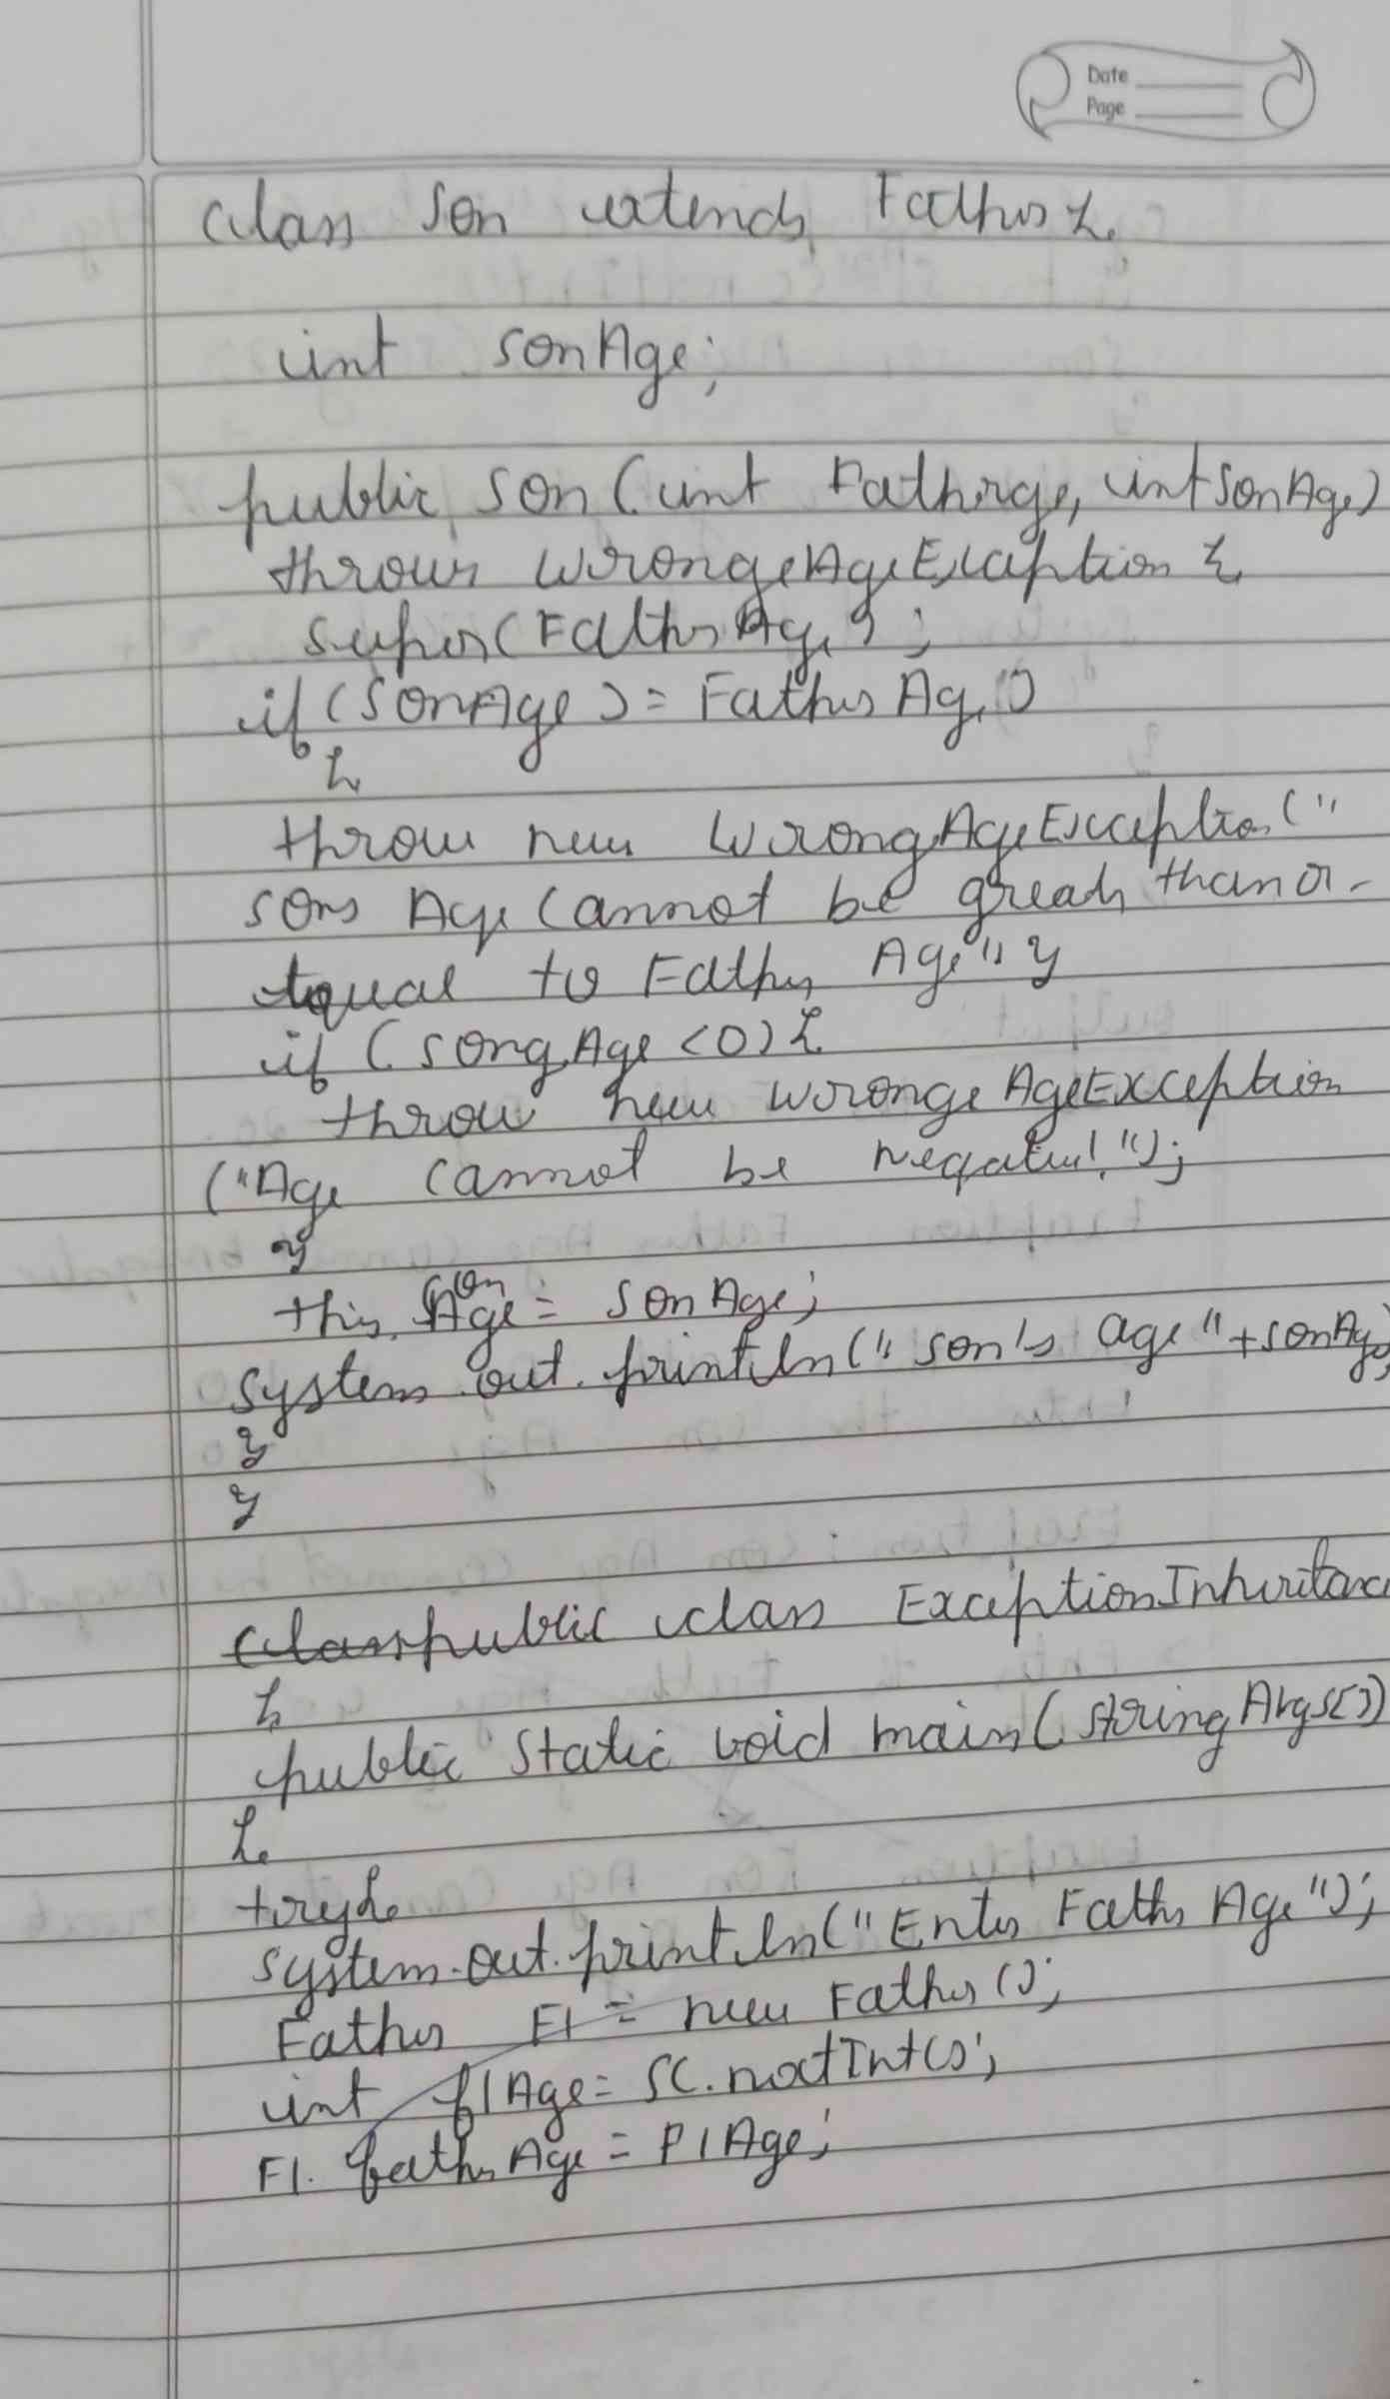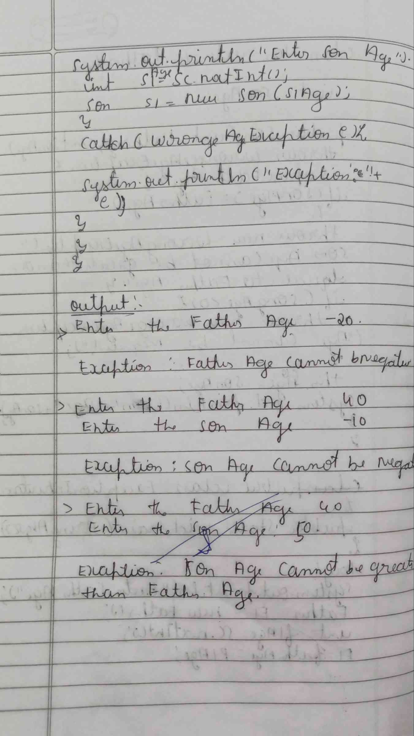

**CODE :**

**class WrongAgeException extends Exception {**

**public WrongAgeException(String message) {**

**super(message); } }**

**class Father {**

**int fatherAge;**

**public Father(int age) throws WrongAgeException {**

**if (age < 0) {**

**throw new WrongAgeException("Father's age cannot be negative!");**

**}**

**this.fatherAge = age;**

**System.out.println("Father's Age: " + fatherAge); } }**

**class Son extends Father {**

**int sonAge;**

**public Son(int fatherAge, int sonAge) throws WrongAgeException {**

**super(fatherAge);**

**if (sonAge < 0) {**

**throw new WrongAgeException("Son's age cannot be negative!");**

**}**

**if (sonAge >= fatherAge) {**

**throw new WrongAgeException("Son's age cannot be greater than or equal to father's age!");**

**}**

**this.sonAge = sonAge;**

**System.out.println("Son's Age: " + sonAge); } }**

**public class ExceptionMain {**

**public static void main(String[] args) {**

**java.util.Scanner sc = new java.util.Scanner(System.in);**

**try {**

**System.out.print("Enter Father's Age: ");**

**int fatherAge = sc.nextInt();**

**System.out.print("Enter Son's Age: ");**

**int sonAge = sc.nextInt();**

**Son son = new Son(fatherAge, sonAge);**

**} catch (WrongAgeException e) {**

**System.out.println("Exception: " + e.getMessage());**

**} catch (Exception e) {**

**System.out.println("Unexpected Exception: " + e);} } }**

**OUTPUT :**

